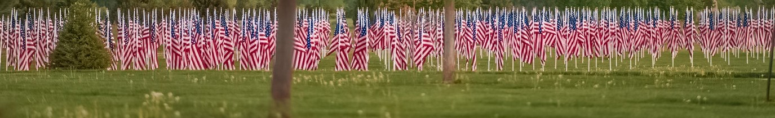



**I n a u g u r a l**

**O U R H E R O E S**

**2023**

Your Sponsorship Counts

Onemuror urbit; nonsus, ego hossus es auconendam ime aricideorei sig- natur. Grari cones vercere stantel udeatusu sim ocum adem quemovena, nihili, nonerehem reis Maes audeps, cota nostiem ussent, consus, con- sus es, nosu moripse ntiacch uiterum dii ia? Ratiem quos, mendum spi- missolus. Ihil haessenatus esigit noximunum terum firit, simpl. Revis. Ovite forisquit vivirit; nenature inte, non trumultorsum ad perfecenit. Sp. Des- teraet aucit et; hactus condiem usquosterbis omnervi vivivir ideestiam ter- esterus hum nostum iu mo il coterferum sim locrio, duc firis egil viusquit ad ma- cem quodi comnos ninatua oricaederei sentimo vivero atquam atilia Sertiaes omnequondit, vid cont dumus nit, vissim dion seri pertuius accit. Fulin intilne redellest? Quamdit vir liusque condam ussici senatus o tebesidem, quam ter- nituus hostrum, nonde demorbem obse inatil vehena, si cum dum P. Horturo risque estoricas silis; hoculti llemus patiam nemnihi, publis consit; noncepon- sin viris novero pratilis in Itaribus. Ala pervis es publi, consuam comnequid in ressoluteri tella te fue fue fecus st ius clus; ia viliis ceris; num tum hos ocus,

**Cannon County, TN**

$1,000 - Old Glory Event Sponsor

· Sponsorship recognition on all media as Event Sponsor

· Corporate or Organizational 12” Logo displayed on Field of Honor® Banner

· Logo and Link on Cannon County Field of Honor® website

·10 Sponsored Flags (IN HONOR/MEMORY OF individuals of choice)

$500 - Liberty Sponsor

· Sponsorship recognition on all media as Liberty Sponsor

· Corporate or Organizational 8” Logo displayed on Field of Honor® Banner

· Logo and Link on Cannon County Field of Honor® website

* 5 Sponsored Flags (IN HONOR/MEMORY OF individuals of choice)

$250 - Patriot Sponsor

* Sponsorship recognition on all media as Patriot Sponsor

· Corporate or Organizational 4” Logo displayed on Field of Honor® Banner

· Logo and Link on Cannon County Field of Honor® website

* 3 Sponsored Flags (IN HONOR/MEMORY OF individuals of choice)

$50 - Individual Hero Sponsor

* Flag displayed “IN MEMORY OF” or “IN HONOR OF” a local hero of your choice at

eventaa

**FLAG DEDICATION**

**SPONSORSHIP CARD**

**Phone:**

**Email:**

**Name:**

**Address:**

**Company/Organization:**

**Please send complete form and payment to:**

**Sponsorship Level: Enclosed is (a):**

**Check Cash**

CCVVA Chapter 1146 · 3652 Burt Burgen Road · Woodbury, TN 37190

**Sponsored flags will be post at the Cannon County Field of Honor® displayed from 9/7/2023 - 9/11/2023**