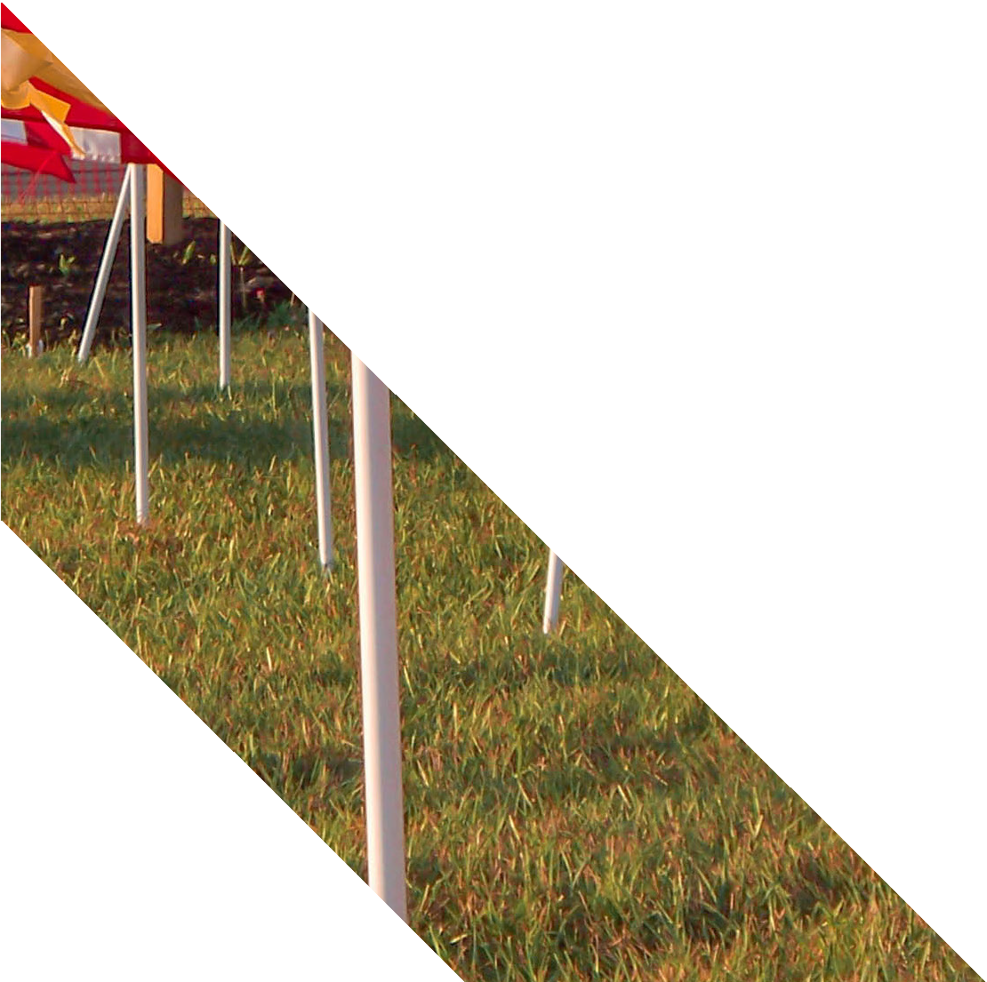

**F I E L D O F H O P E**

**February 24th - 26th**

**VETERANS MEMORIAL PARK**

2827 South Military Rd

Flagstaff, AZ 84707

The Rotary Club of Jurupa Valley is pleased

to present the First

Annual Field of Honor®, where members of the community

can honor their heroes

of flags will be on viewing 24 hours be purchased

with an American Flag. Hundreds

display in perfect rows for public a day during the event. Flags can in memory or honor of service

members, past and present, regardless of where

they live. Proceeds from the Field of Honor® will benefit the Veterans memorial Park.

**Visit our website at:** [**www.healingfield.org/flagstaff18**](http://www.healingfield.org/flagstaff18)