**November 9th - 12th**

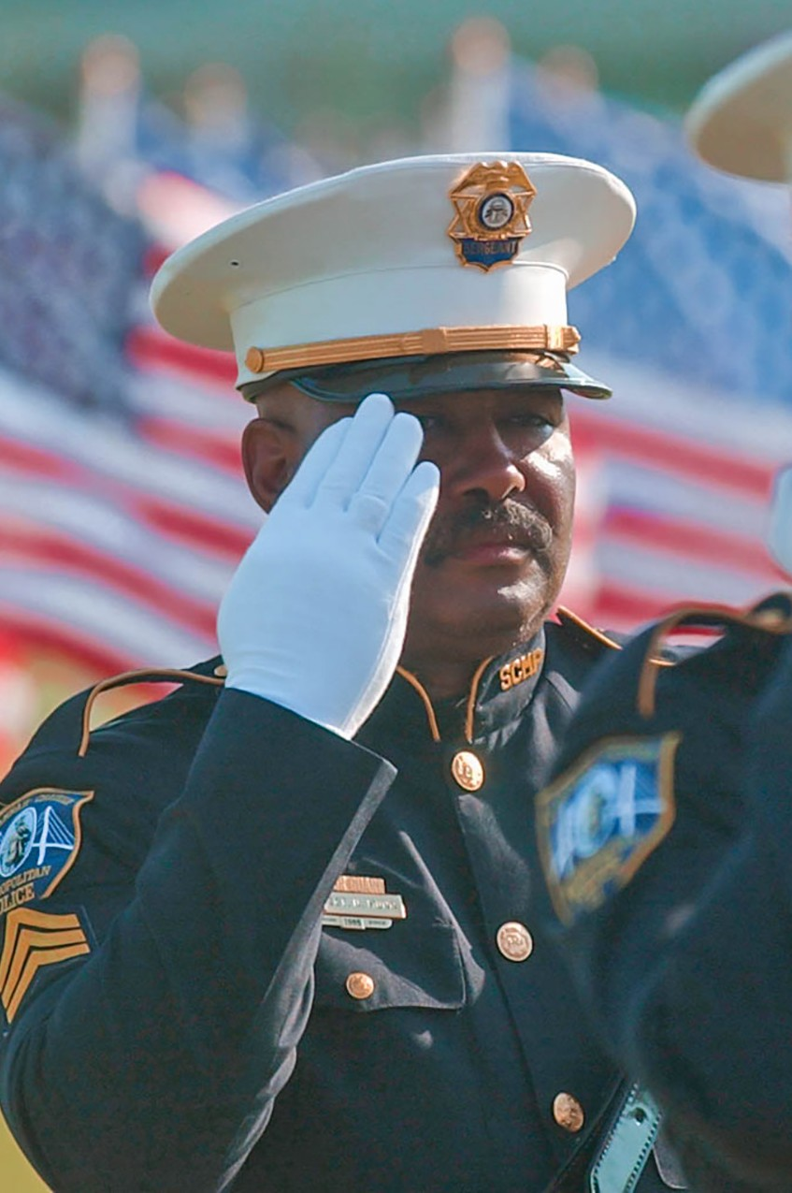

**SPONSOR FORM**

**BENEFITTING CHARITIES**

Exchange Club Parenting Skills Center

**Name:**

**Address:**

**City:**

**HOSTED BY**

**State:**

Holy Emmanuel Lutheran Church

**Phone:**

**Email:**

**LOCAL ORGANIZING COMMITTEE**

**Level of Sponsorship:**

Project Chair - Bill Solder

Co-Chair - John Wagner Volunteer Chair - Diane Pike

**Total Flags: @$25/ea =**

**Check #**

**Credit Card**

**Cash**

**Dedication:**

**VETERANS PARK/SEAVIEW PARK**

10 Seaview Avenue

Norwalk, CT 45612

**2022**

**FLAGS CAN ALSO BE PURCHASED ONLINE AT:**

[WWW.HEALINGFIELD.ORG/FLAGSTAFF18](http://WWW.HEALINGFIELD.ORG/FLAGSTAFF18)

**HOW CAN I HELP?**

Sponsor a Flag! Flags are sponsored for

$35, and the sponsor will retain the flags at the closing of the event.

It is the Healing Field- and in a very short amount of time, it has helped thousands of people in countless communities across America heal emotional wounds, grow closer, and celebrate the full glory of patriotism.

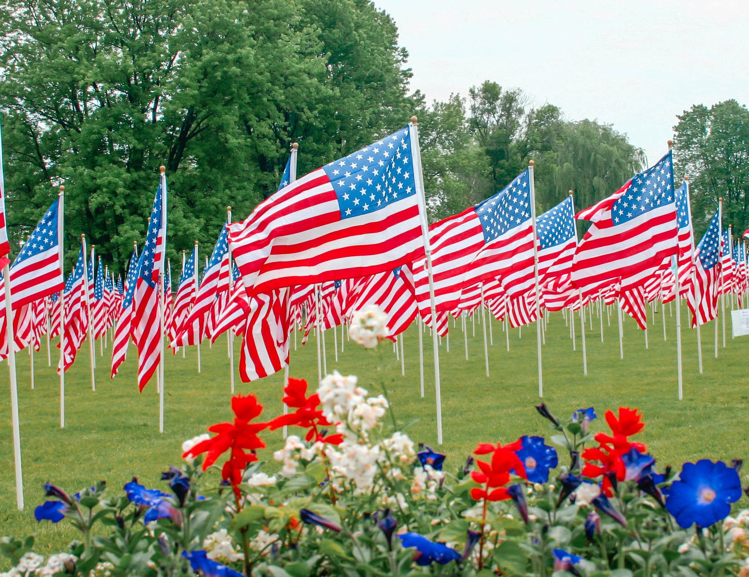

**OUR PURPOSE**

The Stars and Stripes will appear in an awe-inspiring panorama of red, white, and blue on the grassy lawns of Veterans Park/Seaview Park. Hundreds of full-sized flags will fly on seven and a half foot flagpoles to honor our veterans.

**SPONSOR PACKAGES**

**PLATINUM - $1,000**

* Company logo on all electronic & printed media
* PR opportunity to have a spokesperson interviewed by the media
* VIP seating at the dedication ceremony
* Your employees and executives on the field during setup and tear-down in team wear
* Commemorative gift photo and flag for display in your facility after the event
* Kids booths sponsor (Operation Dead Hero, Operation Thank You, flag folding instructions

It is the Healing Field- and in a very short amount of time, it has helped thousands of people in countless communities across America heal emotional wounds, grow closer, and celebrate the full glory of patriotism.

All are invited to visit this Field of Honor® display and walk among the posted flags. Proceeds will benefit the Exchange Club Parenting Skills Center to help break the cycle of child abuse and neglect by providing home based remedial and preventive intervention to abused and/or neglected children or those considered to be "at risk" and their families.

**GOLD - $750**

* Company logo on all electronic & printed media
* Logo & link on Healing Field webpage
* VIP seating at the dedication ceremony
* Your employees and executives on the field during setup and tear-down in team wear

**BENEFITTING CHARITY**

The Stars and Stripes will appear in an awe-inspiring panorama of red, white, and blue on the grassy lawns of Veterans Park/Seaview Park. Hundreds of full-sized flags will fly on seven and a half foot flagpoles to honor our veterans.

**SILVER - $500**

* Logo and link on Healing Field webpage
* Listing on sponsor field banner
* Your employees and executives on the field during setup and tear-down in team wear.

**IN KIND**

· We have many needs for in-kind donations at the Healing Field. In kind sponsors will receive recognition at the field and other benefits based on the value of the donation.

All are invited to visit this Field of Honor® display and walk among the posted flags. Proceeds will benefit the Exchange Club Parenting Skills Center to help break the cycle of child abuse and neglect by providing home based remedial and preventive intervention to abused and/or neglected children or those considered to be "at risk" and their families.