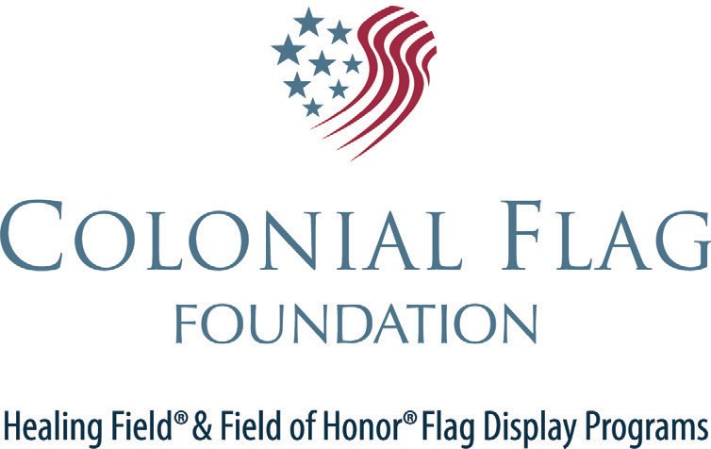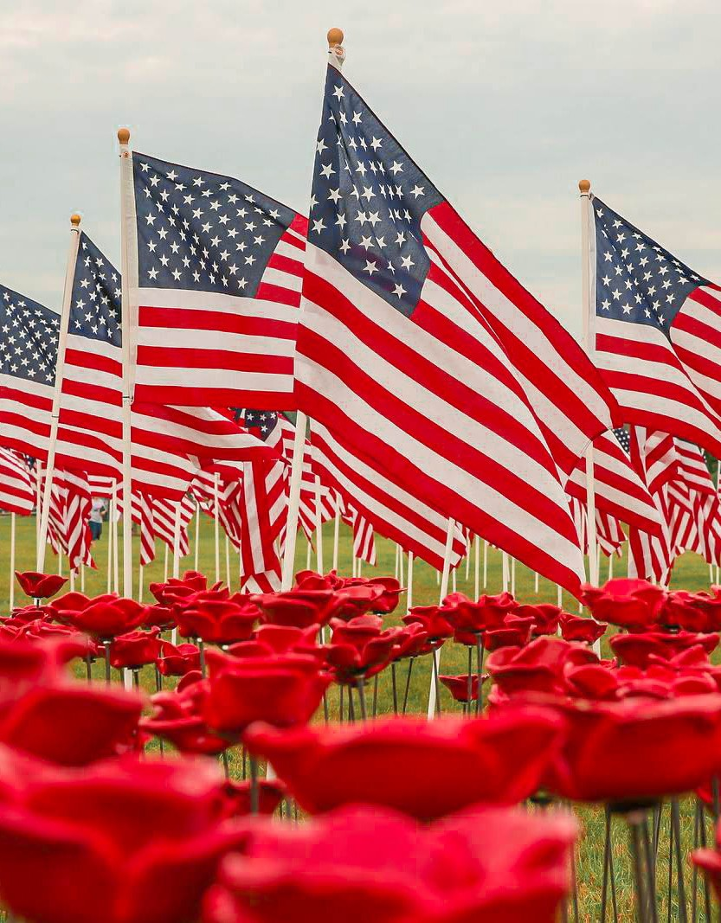

**2022**

**March 24th - 26th**

Open Arms Christian Early Childhood Center and the ministries of the holy Emmanuel Lutheran Church

**Total Flags: @$25/ea =**

**MORE INFORMATION**

**HOSTED BY**

**BENEFITTING**

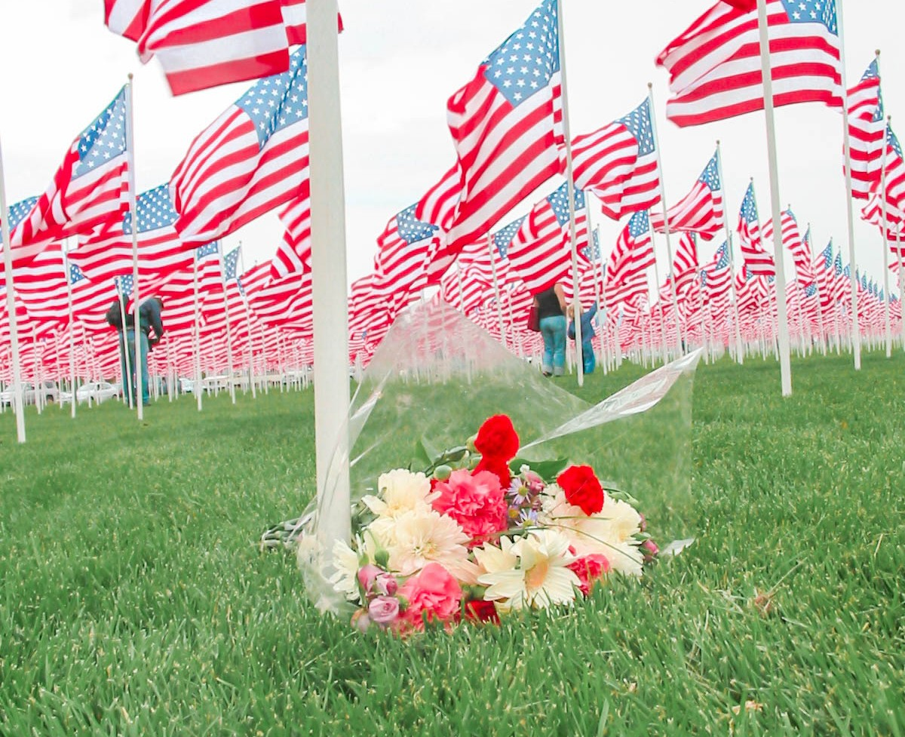

**SPONSORSHIP FORM**

Holy Emmanuel Lutheran Church

**Name:**

**Address:**

**City:**

**State:**

[www.healingfield.com/flagstaff18](http://www.healingfield.com/flagstaff18)

**Phone:**

**Email:**

**Level of Sponsorship:**

**F I E L D O F H O P E**

**Check #**

Flagstaff, AZ

**Credit Card**

**VETERANS MEMORIAL FIELD**

**Cash**

123 Park Street

Flagstaff, AZ 80440

**FLAGS CAN ALSO BE PURCHASED ONLINE AT:**

[WWW.HEALINGFIELD.ORG/FLAGSTAFF18](http://WWW.HEALINGFIELD.ORG/FLAGSTAFF18)

**Dedication:**

***OUR NEEDS:***

**Bottled Water Staging**

**Hotel Rooms**

**4 Wheelers/Golf Carts**

The panorama of red, white, and blue is hard to adequately describe, but once experienced, it is not forgotten. There will be no charge to visit the Field of Honor® display and all are invited to walk with us through the ordered rows of flags

**OUR STORY**

In June 2018, the Holy Emmanuel Lutheran Church will host its inaugural Field of Honor®. This inspirational posting of the Stars and Stripes will feature flags standing in a solemn formation in Honor of the Heroes in Our Lives.

Those killed in the 9/11 terrorist attacks, the victims of child abuse, teachers, fire-fighters, police, first responders, military, and veterans may be honored with the display of U.S. flags. Flags are sponsored for $40, and the sponsors will retain the flag at the close of the event to be displayed in surrounding communities as mementos of this awe-inspiring event. Flags may be shipped to sponsors for an additional $5 for those unable to pick up their flags at the conclusion of the event.

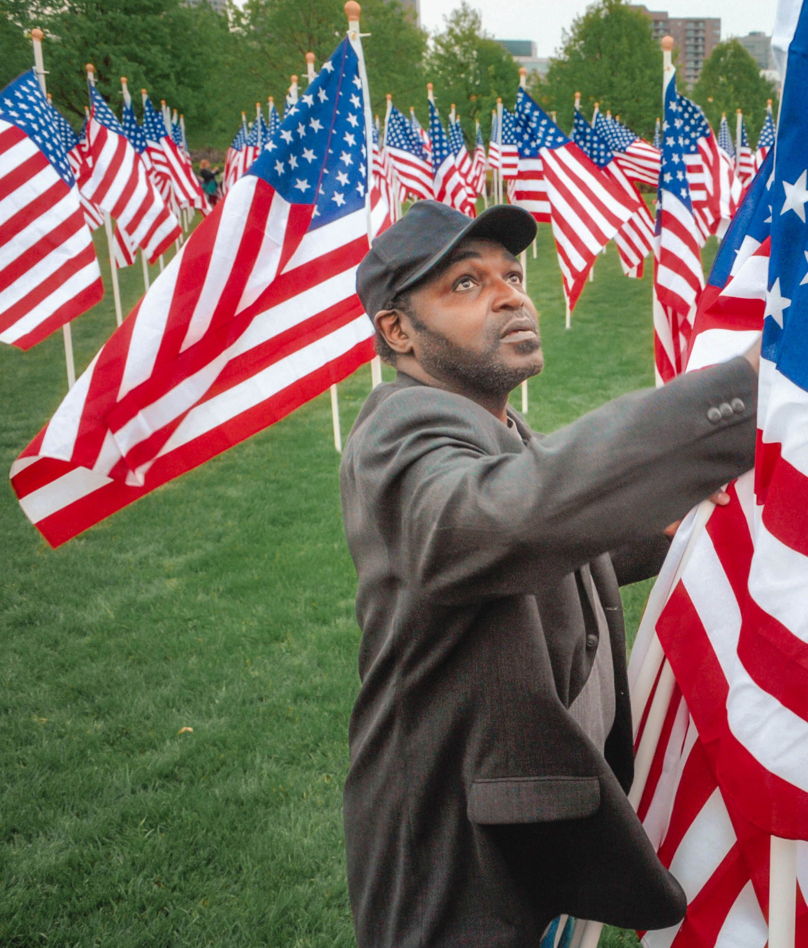

**SPONSORSHIP OPPORTUNITIES**

***PLATINUM · $5,000***

* Company logo on all electronic & printed media
* PR opportunity to have a spokesperson interviewed by the media
* VIP seating at the dedication ceremony
* Your employees and executives on the field during setup and tear-down in team wear
* Commemorative gift photo and flag for display in your facility after the event

***GOLD · $2,500***

* Company logo on group sponsorship banner
* Logo & link on Healing Field webpage
* VIP seating at the dedication ceremony
* Your employees and executives on the field during setup and tear-down in team wear

**This is an event not to be missed.**

***SILVER · $1,000***

**BENEFITTING CHARITY**

The funds raised through the Field of Honor® flag display will benefit the Open Arms Christian Early Childhood Center and the ministries of the Holy Emmanuel Lutheran Church.

* Listing on the website
* Listing on sponsor banner
* Your employees and executives on the field during setup and tear-down in team wear.

***FLAG SPONSORSHIP· $100***

· Receive a commemorative flag that has flown on the Field.

Flag can be picked up at the end of the event, or alternatively, mailed directly to you.

***IN KIND***

· In kind sponsors will receive recognition at the field and other benefits based on the value of the donation.

**Marking Paint**

**Printing Services Night Security**

**Lighting**

**Banners & Signs Sound System**