**Thanks to our sponsors!**

Liberty

**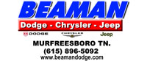 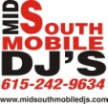**

Patriot

**ketron_logo_transparent-sm**  **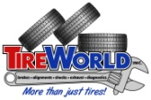 **

**I:\2012 Fields\2012 Fields\TN Murfreesboro12\Sponsor logos\Logo - color.png**All American **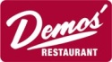 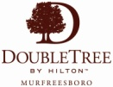 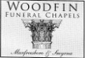 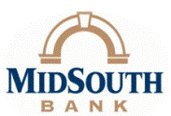**

Murfreesboro Exchange Club **Atmos-Energy FSS-logo**

Guardian

**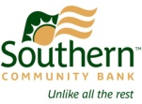 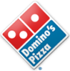 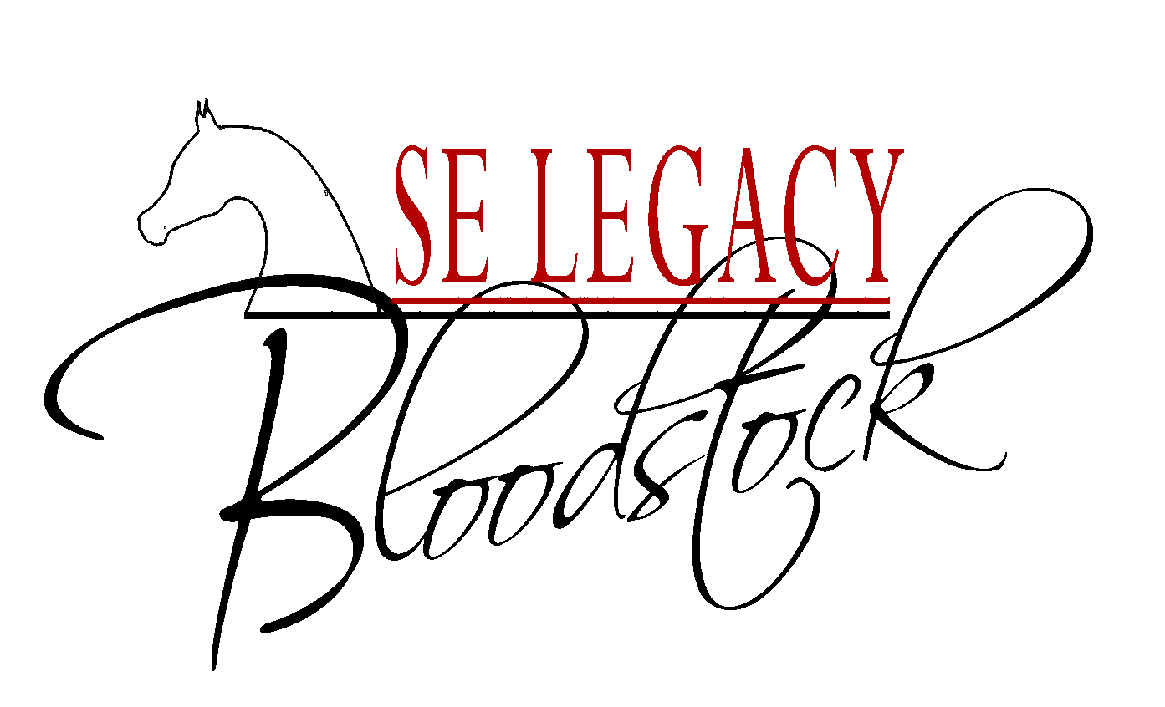** 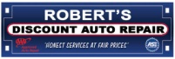 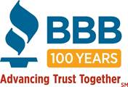    
  
Bud Morris, State Farm JD Witherspoon

Ernest Burgess  
Kim, Geoffrey, Skyler & Chandler Herring

Bill & Joyce Boner

Beverly, Meghan & David Nipper

In Kind  
** 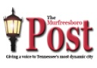 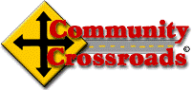**

** 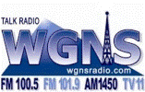 **

**File456**

**Golf Carts Fore Less **

**Murfreesboro Kubota** 

* **Florida Bros. Napa Auto Parts** 

**HobNob Murfreesboro **

**Farrer Brothers Hardware&Equipment**