Healing Field Reminds Billings of 9/11 Tools
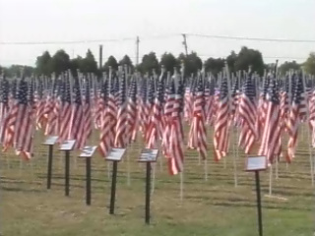

By Kenneth Wong
Story Published: Sep 8, 2011 at 12:32 PM MDT
Story Updated: Sep 8, 2011 at 2:59 PM MDT

Multimedia
- Watch The Video
BILLINGS - A field of red, white, and blue aims to remind Billings residents of the horrors of Sept. 11th.
This is the second year for the Billings Healing Field, and 2011 is the first time the Healing Field display was hosted on the campus of MSU-Billings' College of Technology, partly as a result of the new 9/11 memorial at the CoT, which contains a part of the World Trade Center.
Volunteers worked through Thursday morning to install over 1,000 flags. Organizers say they hope kids who are too young to remember the attacks personally will find the display educational.
"I think if they can learn more about what happened on that day, and hear stories from people that were around on that day, that's pretty powerful," said Kris Koessl, Co-Chairman of Billings Healing Field.
There will be a dedication ceremony on Sept. 11th at 2:00 p.m.

